https://computing.llnl.gov/tutorials/parallel_comp/#Designing

Introduction to Parallel Computing

Author: Blaise Barney, Lawrence Livermore National Laboratory

Abstract
This tutorial is the first of eight tutorials in the 4+ day "Using LLNL's Supercomputers" workshop. It is intended to provide only a very quick overview of the extensive and broad topic of Parallel Computing, as a lead-in for the tutorials that follow it. As such, it covers just the very basics of parallel computing, and is intended for someone who is just becoming acquainted with the subject and who is planning to attend one or more of the other tutorials in this workshop. It is not intended to cover Parallel Programming in depth, as this would require significantly more time. The tutorial begins with a discussion on parallel computing - what it is and how it's used, followed by a discussion on concepts and terminology associated with parallel computing. The topics of parallel memory architectures and programming models are then explored. These topics are followed by a series of practical discussions on a number of the complex issues related to designing and running parallel programs. The tutorial concludes with several examples of how to parallelize simple serial programs.
Overview

What is Parallel Computing?
Serial Computing:
- Traditionally, software has been written for serial computation:
  - A problem is broken into a discrete series of instructions
  - Instructions are executed sequentially one after another
  - Executed on a single processor
  - Only one instruction may execute at any moment in time
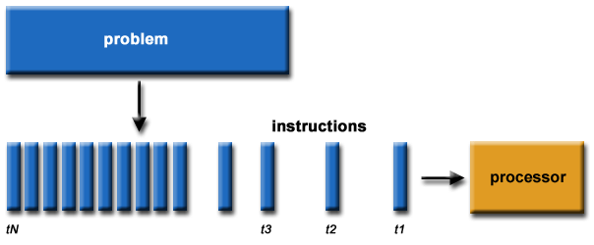
For example:
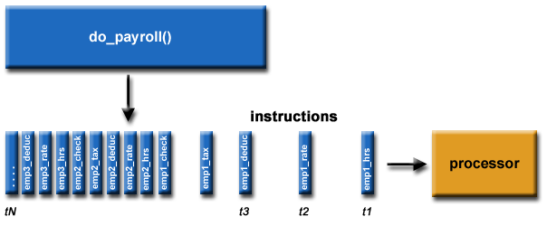
Parallel Computing:
- In the simplest sense, parallel computing is the simultaneous use of multiple compute resources to solve a computational problem:
  - A problem is broken into discrete parts that can be solved concurrently
  - Each part is further broken down to a series of instructions
  - Instructions from each part execute simultaneously on different processors
  - An overall control/coordination mechanism is employed
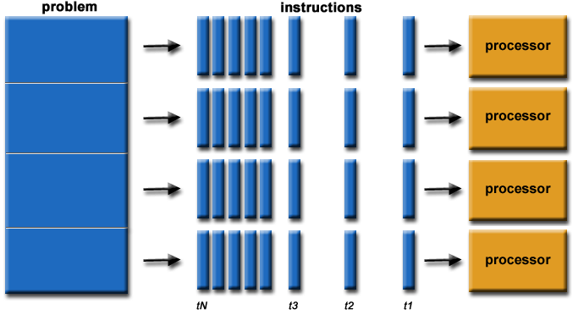
For example:
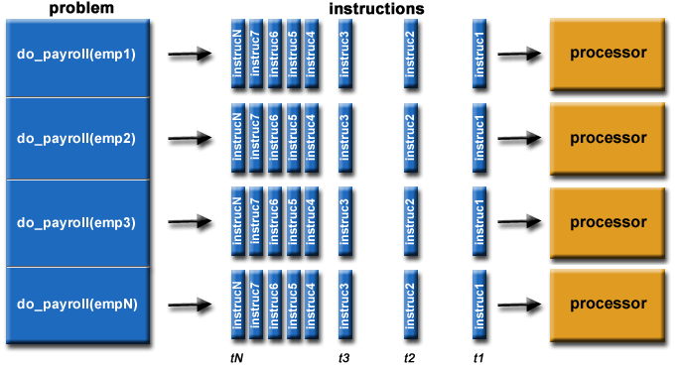
- The computational problem should be able to:
  - Be broken apart into discrete pieces of work that can be solved simultaneously;
  - Execute multiple program instructions at any moment in time;
  - Be solved in less time with multiple compute resources than with a single compute resource.
- The compute resources are typically:
  - A single computer with multiple processors/cores
  - An arbitrary number of such computers connected by a network
Parallel Computers:
- Virtually all stand-alone computers today are parallel from a hardware perspective:
  - Multiple functional units (L1 cache, L2 cache, branch, prefetch, decode, floating-point, graphics processing (GPU), integer, etc.)
  - Multiple execution units/cores
  - Multiple hardware threads
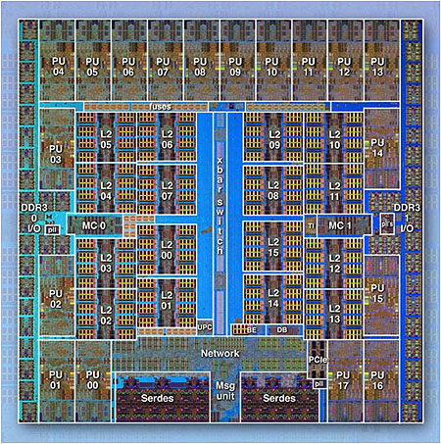
IBM BG/Q Compute Chip with 18 cores (PU) and 16 L2 Cache units (L2)
- Networks connect multiple stand-alone computers (nodes) to make larger parallel computer clusters.
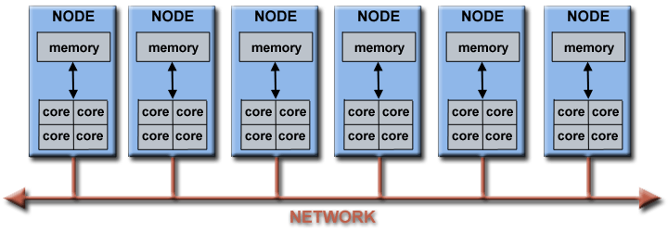
- For example, the schematic below shows a typical LLNL parallel computer cluster:
  - Each compute node is a multi-processor parallel computer in itself
  - Multiple compute nodes are networked together with an Infiniband network
  - Special purpose nodes, also multi-processor, are used for other purposes
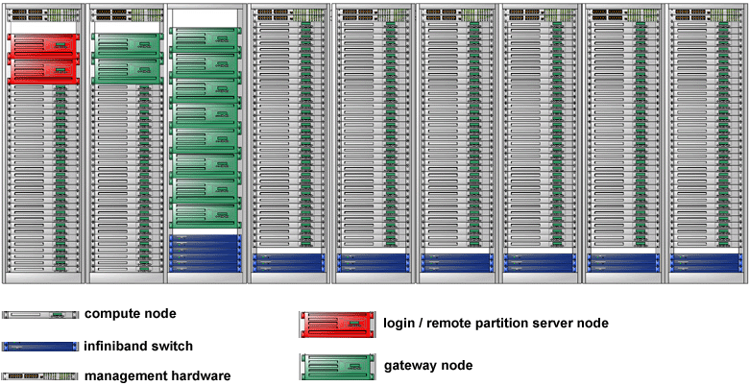
- The majority of the world's large parallel computers (supercomputers) are clusters of hardware produced by a handful of (mostly) well known vendors.
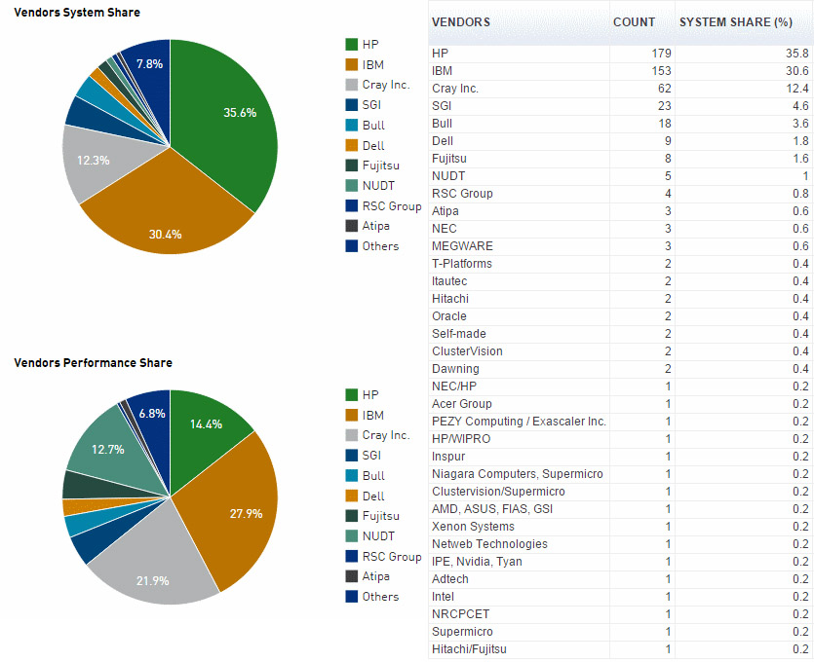
Source: Top500.org

Overview

Why Use Parallel Computing?
The Real World is Massively Parallel:
- In the natural world, many complex, interrelated events are happening at the same time, yet within a temporal sequence.
- Compared to serial computing, parallel computing is much better suited for modeling, simulating and understanding complex, real world phenomena.
- For example, imagine modeling these serially:
Main Reasons:
- SAVE TIME AND/OR MONEY:
  - In theory, throwing more resources at a task will shorten its time to completion, with potential cost savings.
  - Parallel computers can be built from cheap, commodity components.
- SOLVE LARGER / MORE COMPLEX PROBLEMS:
  - Many problems are so large and/or complex that it is impractical or impossible to solve them on a single computer, especially given limited computer memory.
  - Example: "Grand Challenge Problems" (en.wikipedia.org/wiki/Grand_Challenge) requiring PetaFLOPS and PetaBytes of computing resources.
  - Example: Web search engines/databases processing millions of transactions every second
- PROVIDE CONCURRENCY:
  - A single compute resource can only do one thing at a time. Multiple compute resources can do many things simultaneously.
  - Example: Collaborative Networks provide a global venue where people from around the world can meet and conduct work "virtually".
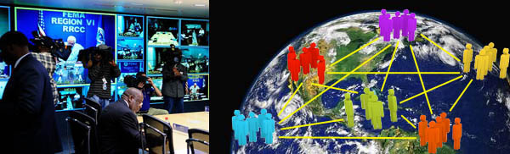
- TAKE ADVANTAGE OF NON-LOCAL RESOURCES:
  - Using compute resources on a wide area network, or even the Internet when local compute resources are scarce or insufficient.
  - Example: SETI@home (setiathome.berkeley.edu) over 1.5 million users in nearly every country in the world. Source: www.boincsynergy.com/stats/ (June, 2015).
  - Example: Folding@home (folding.stanford.edu) uses over 160,000 computers globally (June, 2015)
- MAKE BETTER USE OF UNDERLYING PARALLEL HARDWARE:
  - Modern computers, even laptops, are parallel in architecture with multiple processors/cores.
  - Parallel software is specifically intended for parallel hardware with multiple cores, threads, etc.
  - In most cases, serial programs run on modern computers "waste" potential computing power.
Intel Xeon processor with 6 cores and 6 L3 cache units
The Future:
- During the past 20+ years, the trends indicated by ever faster networks, distributed systems, and multi-processor computer architectures (even at the desktop level) clearly show that parallelism is the future of computing.
- In this same time period, there has been a greater than 500,000x increase in supercomputer performance, with no end currently in sight.
- The race is already on for Exascale Computing!
  - Exaflop = 10¹⁸ calculations per second
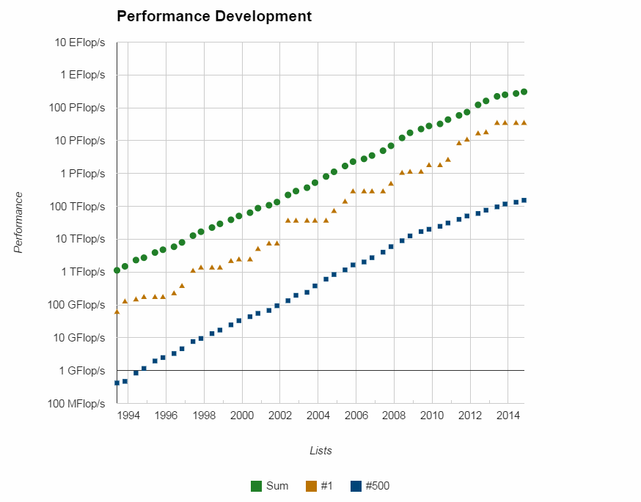
Source: Top500.org

Who is Using Parallel Computing?
Science and Engineering:
- Historically, parallel computing has been considered to be "the high end of computing", and has been used to model difficult problems in many areas of science and engineering:
- Atmosphere, Earth, Environment  - Physics - applied, nuclear, particle, condensed matter, high pressure, fusion, photonics  - Bioscience, Biotechnology, Genetics  - Chemistry, Molecular Sciences  - Geology, Seismology | - Mechanical Engineering - from prosthetics to spacecraft  - Electrical Engineering, Circuit Design, Microelectronics  - Computer Science, Mathematics  - Defense, Weapons
Industrial and Commercial:
- Today, commercial applications provide an equal or greater driving force in the development of faster computers. These applications require the processing of large amounts of data in sophisticated ways. For example:
- "Big Data", databases, data mining  - Oil exploration  - Web search engines, web based business services  - Medical imaging and diagnosis  - Pharmaceutical design | - Financial and economic modeling  - Management of national and multi-national corporations  - Advanced graphics and virtual reality, particularly in the entertainment industry  - Networked video and multi-media technologies  - Collaborative work environments
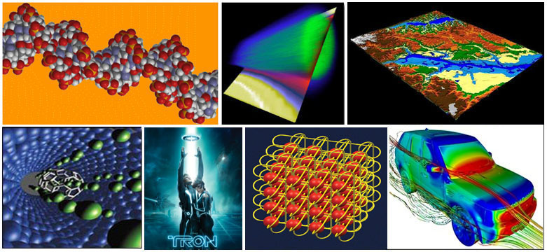
Global Applications:
- Parallel computing is now being used extensively around the world, in a wide variety of applications.

